# EXPT NO: 1 A python program to implement univariate regression bivariate regression and multivariate regression.

**DATE: 23.08.2024**

# AIM:

To write a python program to implement univariate regression, bivariate regression and multivariate regression.

# PROCEDURE:

Implementing univariate, bivariate, and multivariate regression using the Iris dataset involve the following steps:

# Step 1: Import Necessary Libraries

First, import the libraries that are essential for data manipulation, visualization, and model building.

|  |
| --- |
| import numpy as np import pandas as pd import seaborn as sns  import matplotlib.pyplot as plt  from sklearn.model_selection import train_test_split  from sklearn.linear_model import LinearRegression |
| from sklearn.metrics import mean_squared_error, r2_score |

# Step 2: Load the Iris Dataset

The Iris dataset can be loaded and display the first few rows of the dataset .

|  |
| --- |
| # Load the Iris dataset |
| iris = sns.load_dataset('iris')  # Display the first few rows of the dataset print(iris.head()) |

# OUTPUT :

**Step 3: Data Preprocessing**

Ensure the data is clean and ready for modeling. Since the Iris dataset is clean, minimal preprocessing is needed.

# Check for missing values print(iris.isnull().sum())

# Display the basic statistical details print(iris.describe())

# OUTPUT :

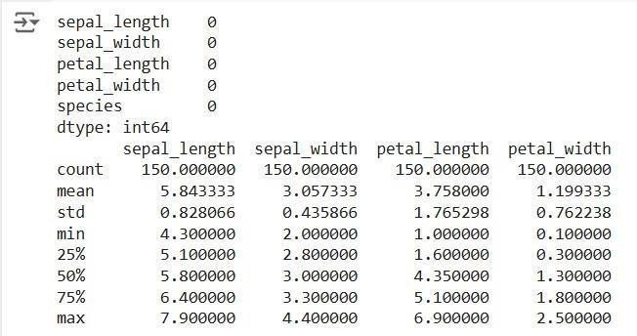

**Step 4: Univariate Regression**

Univariate regression involves predicting one variable based on a single predictor.

# : Select the Features

Choose one feature (e.g., sepal_length) and one target variable (e.g., sepal_width).

X_uni = iris[['sepal_length']] y_uni = iris['sepal_width']

# : Split the Data

Split the data into training and testing sets.

Fit the linear regression model on the training data.

X_uni_train, X_uni_test, y_uni_train, y_uni_test = train_test_split(X_uni, y_uni,

test_size=0.2, random_state=42)

# : Train the model

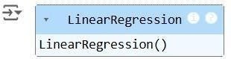

uni_model = LinearRegression() uni_model.fit(X_uni_train, y_uni_train)

* 1. **: Make Predictions**

Use the model to make predictions on the test data.

y_uni_pred = uni_model.predict(X_uni_test)

# : Evaluate the Model

Evaluate the model performance using metrics like Mean Squared Error (MSE) and R-squared.

print(f'Univariate MSE: {mean_squared_error(y_uni_test, y_uni_pred)}') print(f'Univariate R-squared: {r2_score(y_uni_test, y_uni_pred)}')

# OUTPUT :



* 1. **: Visualize the Results**

Visualize the relationship between the predictor and the target variable.

|  |
| --- |
| plt.scatter(X_uni_test, y_uni_test, color='blue') plt.plot(X_uni_test, y_uni_pred, color='red') plt.xlabel('Sepal Length') plt.ylabel('Sepal Width') |
| plt.title('Univariate Regression') plt.show() |

# OUTPUT :

**Step 5 : Bivariate Regression**

Bivariate regression involves predicting one variable based on two predictors.

# : Select the Features

Choose two features (e.g., sepal_length, petal_length) and one target variable (e.g., sepal_width).

X_bi = iris[['sepal_length', 'petal_length']]

y_bi = iris['sepal_width']

# : Split the Data

Split the data into training and testing sets.

X_bi_train, X_bi_test, y_bi_train, y_bi_test = train_test_split(X_bi, y_bi, test_size=0.2, random_state=42)

# : Train the Model

Fit the linear regression model on the training data.

|  |
| --- |
| bi_model = LinearRegression() |
| bi_model.fit(X_bi_train, y_bi_train) |

# OUTPUT :

* 1. **: Make Predictions**

Use the model to make predictions on the test data.

y_bi_pred = bi_model.predict(X_bi_test)

# : Evaluate the Model

Evaluate the model performance using metrics like MSE and R-squared.

print(f'Bivariate MSE: {mean_squared_error(y_bi_test, y_bi_pred)}')

print(f'Bivariate R-squared: {r2_score(y_bi_test, y_bi_pred)}')

OUTPUT :



# : Visualize the Results

Since visualizing in 3D is challenging, we can plot the relationships between the target and each predictor separately.

# Sepal Length vs Sepal Width

plt.subplot(1, 2, 1)

plt.scatter(X_bi_test['sepal_length'], y_bi_test, color='blue')

plt.plot(X_bi_test['sepal_length'], y_bi_pred, color='red')

plt.xlabel('Sepal Length')

plt.ylabel('Sepal Width') # Petal Length vs Sepal Width plt.subplot(1, 2, 2)

plt.scatter(X_bi_test['petal_length'], y_bi_test, color='blue')

plt.plot(X_bi_test['petal_length'], y_bi_pred, color='red')

plt.xlabel('Petal Length')

plt.ylabel('Sepal Width')

plt.suptitle('Bivariate Regression') plt.show()

# OUTPUT :

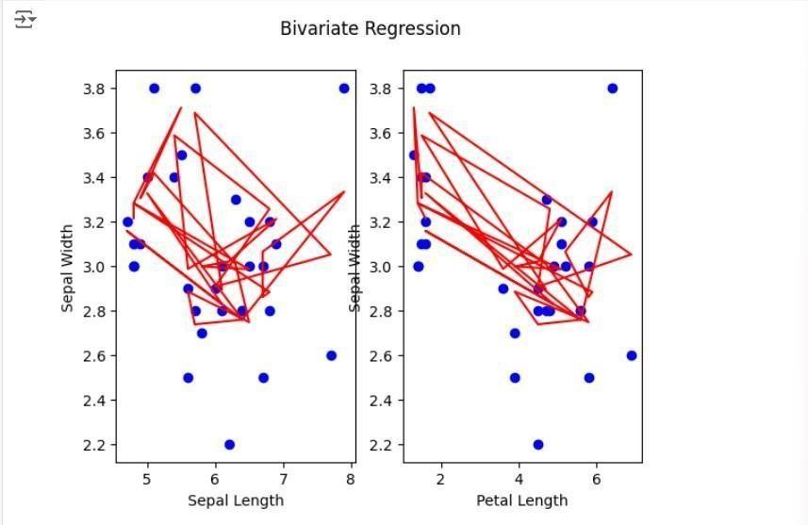

**Step 6: Multivariate Regression**

Multivariate regression involves predicting one variable based on multiple predictors.

# : Select the Features

Choose multiple features (e.g., sepal_length, petal_length, petal_width) and one target variable (e.g., sepal_width).

X_multi = iris[['sepal_length', 'petal_length', 'petal_width']] y_multi

= iris['sepal_width']

# : Split the Data

Split the data into training and testing sets.

X_multi_train, X_multi_test, y_multi_train, y_multi_test =

train_test_split(X_multi,

y_multi, test_size=0.2, random_state=42)

# : Train the Model

Fit the linear regression model on the training data.

multi_model = LinearRegression() multi_model.fit(X_multi_train, y_multi_train)

# OUTPUT :

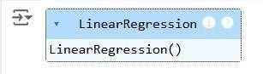

* 1. **: Make Predictions**

Use the model to make predictions on the test data.

y_multi_pred = multi_model.predict(X_multi_test)

# : Evaluate the Model

Evaluate the model performance using metrics like MSE and R-squared.

print(f'Multivariate MSE: {mean_squared_error(y_multi_test, y_multi_pred)}') print(f'Multivariate R-squared: {r2_score(y_multi_test, y_multi_pred)}')

# OUTPUT :



**Step 7: Visualize the multivariate regression**

plt.figure(figsize=(15,4))

plt.subplot(1, 2, 1)

plt.scatter(X_multi_test['sepal_length'], y_multi_test, color='blue')

|  |
| --- |
| plt.plot(X_multi_test['sepal_length'], y_multi_pred, color='red') |
| plt.xlabel('sepal_length')  plt.ylabel('sepal_width') |
| plt.title('Multivariate Regression-1')  plt.show() |
| plt.figure(figsize=(15,4))  plt.subplot(1, 2, 1)  plt.scatter(X_multi_test['petal_length'], y_multi_test, color='blue') |

|  |
| --- |
| plt.plot(X_multi_test['petal_length'], y_multi_pred, color='red')  plt.xlabel('petal_length') |
| plt.ylabel('sepal_width') |
| plt.title('Multivariate Regression-2')  plt.show() |
| plt.figure(figsize=(15,4)) |
| plt.subplot(1, 2, 2 ) |
| plt.scatter(X_multi_test['petal_length'], y_multi_test, color='blue')  plt.plot(X_multi_test['petal_length'], y_multi_pred, color='red') |
| plt.xlabel('petal_length') |

plt.ylabel('sepal_width')

plt.title('Multivariate Regression-3')

plt.show()

# OUTPUT :

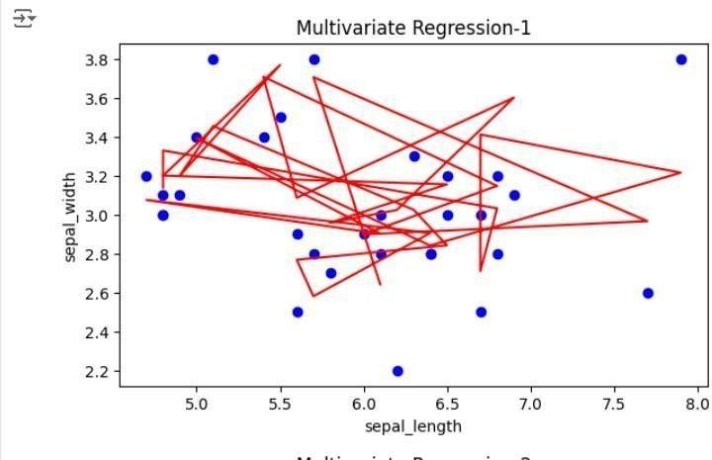

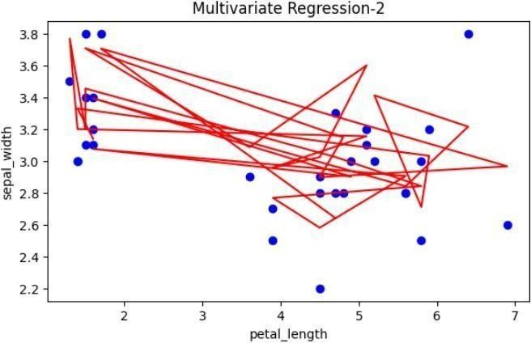

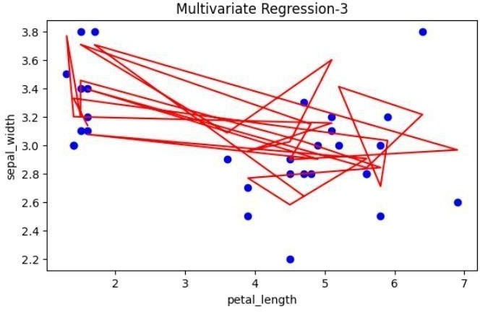

231501077

# Step 8: Interpret the Results

After implementing and evaluating the models, interpret the coefficients to understand the influence of each predictor on the target variable.

print('Univariate Coefficients:', uni_model.coef_)

print('Bivariate Coefficients:', bi_model.coef_) print('Multivariate Coefficients:', multi_model.coef_)

**OUTPUT :**

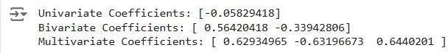

# RESULT:

This step-by-step process will help us to implement univariate, bivariate, and multivariate regression models using the Iris dataset and analyze their

performance.

231501077